**Restaurant Analysis of Swiggy**

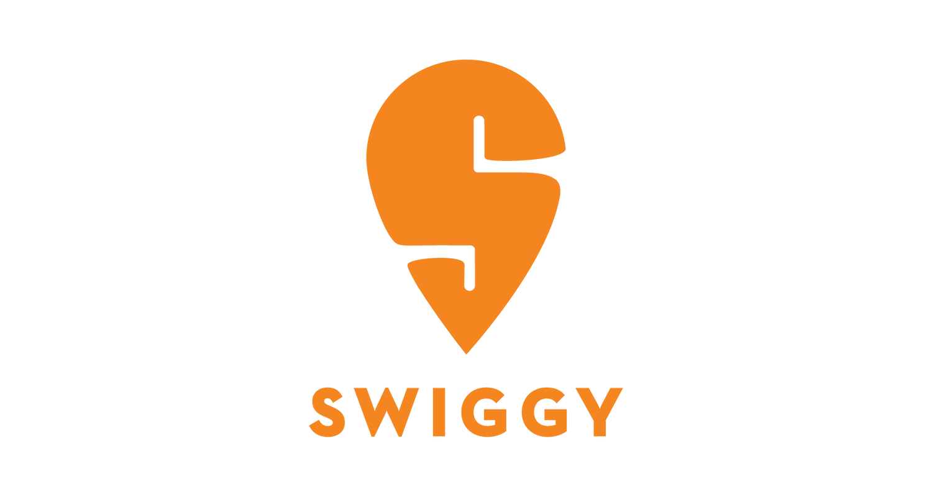

**Indian online food ordering and delivery platform**

**Founded August 2014**

**Headquarters Bangalore, Karnataka, India**

**Area Served 500+ cities across India**

Swiggy is India's leading online food ordering and delivery platform, established in 2014 and headquartered in Bangalore. It connects customers with a diverse range of local restaurants, enabling them to order food for home delivery. The company employs its own delivery personnel to ensure quick service, often within 30 minutes. Since its launch, Swiggy has expanded significantly, operating in over 580 cities and partnering with more than 25,000 restaurants. The platform has diversified its offerings to include services like Swiggy Pop for single-serve meals, Swiggy Cloud for cloud kitchens, and Swiggy Genie for package deliveries. Swiggy has raised substantial funding, totaling $155.5 million from notable investors, and continues to innovate in the food delivery space, enhancing convenience for consumers across India.

**Task 1: Top 10 Areas with Most Restaurants**

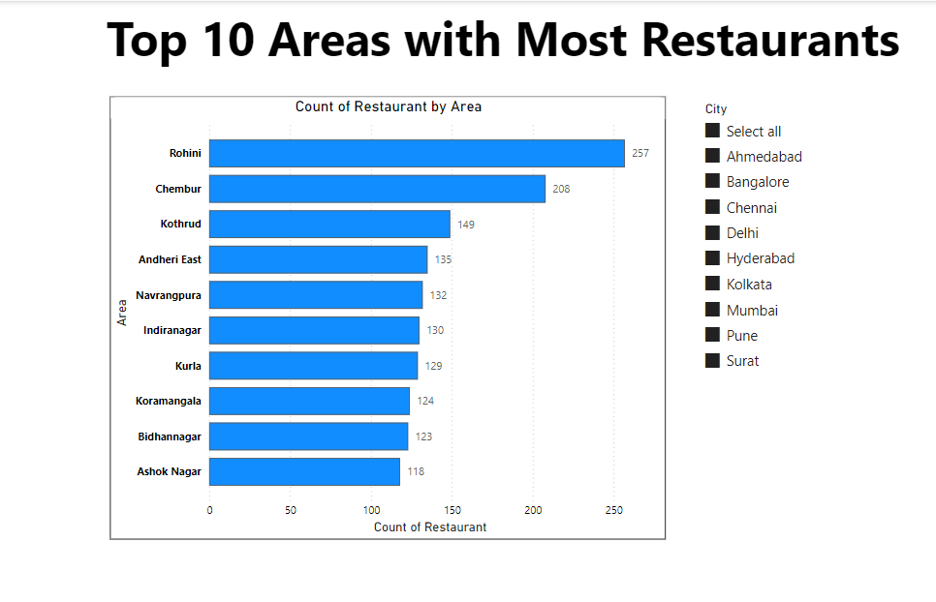

Based on the bar chart provided, the top 10 areas with the highest number of restaurants are:

| Rohini | 257 |
| --- | --- |
| Chembur | 208 |
| Kothrud | 149 |
| Andheri East | 135 |
| Navrangpura | 132 |
| Indiranagar | 130 |
| Kunta | 129 |
| Koramangala | 124 |
| Bidhannagar | 123 |
| Ashok Nagar | 118 |

The report emphasizes the regions where restaurants are most densely concentrated, with Rohini and Chembur standing out. It presents a comprehensive comparison of the number of restaurants in different areas, aiding in the identification of major food hubs. The city filter enables additional exploration of data by city, making it a flexible tool for examining restaurant distribution.

Overall, this data can be used to inform location strategies, market entry decisions, and competitive positioning in the restaurant industry.

**Task 2: Most Popular Food Types Served by Swiggy Restaurants in Each City**

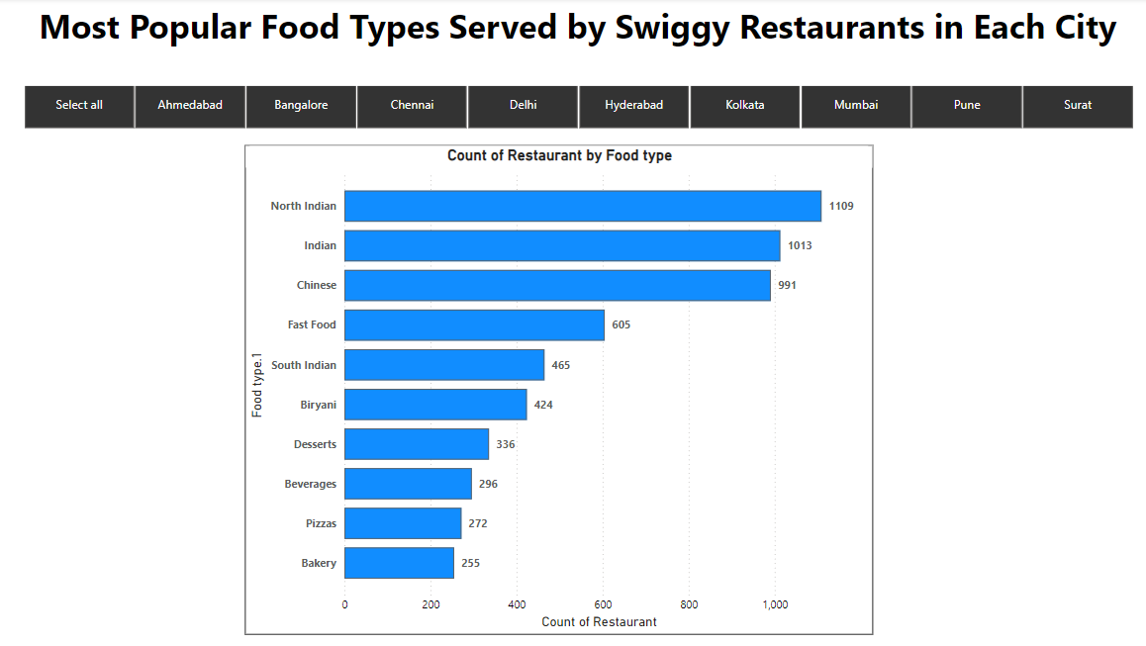

The report provides insights into the count of restaurants serving various food types across different cities.

Most Popular Food Types:

* North Indian cuisine is the most popular, served by 1109 restaurants. Indian cuisine follows closely, with 1013 restaurants. Chinese cuisine is also very popular, with 991 restaurants.

The popularity of the various cuisine varieties served by Swiggy restaurants is highlighted in this research. Chinese, Indian, and North Indian cuisines are the three most popular culinary categories.

It is possible to analyze and break down the popularity of different cuisine types in particular cities by using the city filter. This information can be useful for understanding customer preferences and trends in different regions.

**Task 3: Top Rated Swiggy Restaurants**

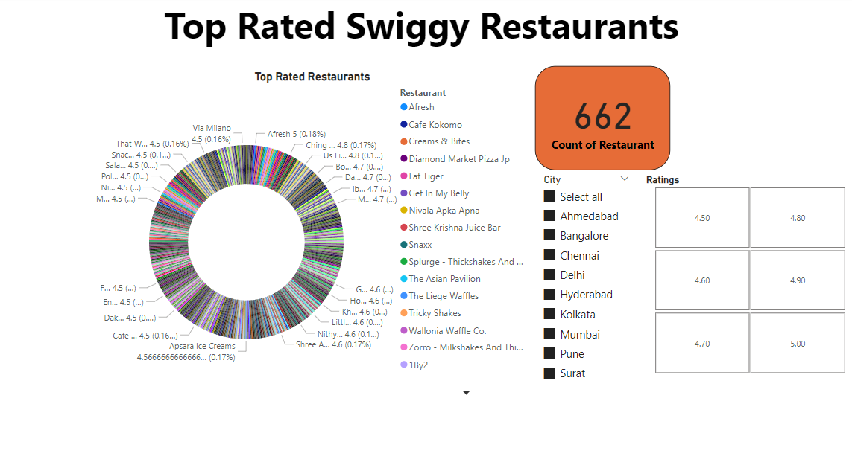

The total count of top-rated Swiggy restaurants is 662.

The pie chart visualizes the distribution of these top-rated restaurants. Each segment represents a restaurant, displaying its name and rating.

The study presents the highest-rated Swiggy restaurants, which are restaurants with ratings between 4.5 and 5.0. It offers a clear picture of the restaurants that consumers in various cities really like. The option to filter by city provides focused insights into the best restaurants in particular areas, which can be useful in figuring out local preferences and patterns in customer satisfaction.

**Task 4: Correlation of Factors Affecting Average Rating**

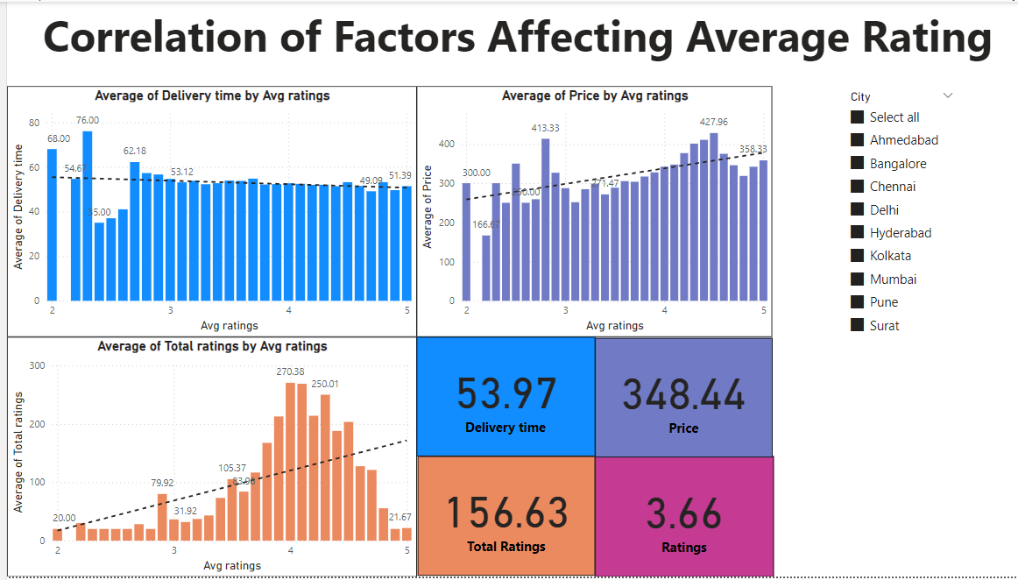

**Delivery Time:** Ratings are positively correlated with shorter delivery times, suggesting that prompt service is critical to customer happiness.

**Cost:** Restaurants with higher ratings are typically more expensive, indicating that patrons may be prepared to spend more for superior cuisine or service.

**Total Ratings:** The number of total ratings for restaurants with a rating of four peaks, possibly signifying the highest level of patron engagement and satisfaction at this rating.

**Overall Ratings:** The average rating of 3.66 indicates that even if a lot of restaurants do well, more may be done to raise average ratings.

By focusing on enhancing delivery times and keeping a balance between price and quality, Swiggy and its restaurant partners may increase consumer satisfaction and ratings.

**Task 5: Correlation Between Restaurant Price and Average Rating**

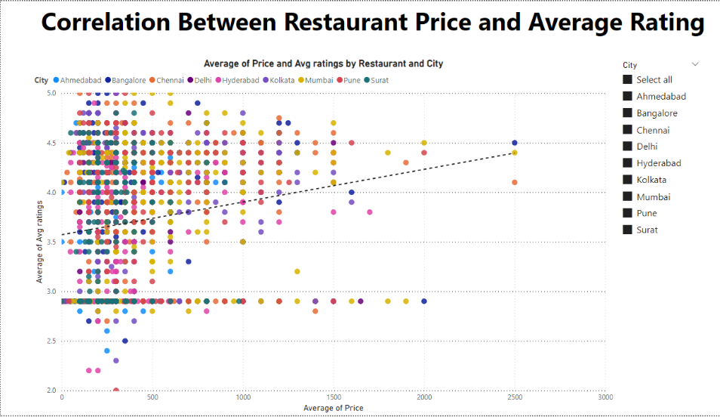

**High Ratings with Moderate Prices:**

A sizable portion of restaurants in the moderate price range of $500 to 1500 get excellent ratings (4.0 to 5.0). This suggests that consumers value affordability combined with good quality or service.

**Low Ratings with Low Prices:**

The majority of restaurants with ratings below 3.0 are located in the lower end of the price spectrum, from 0 to 500. This implies that less expensive eateries can find it difficult to keep their ratings higher, maybe as a result of poorer quality or problems with service.

**Top Rated Expensive Restaurants:**

Very expensive restaurants (over 2000) contain fewer data points, but those that do exist typically have ratings above 4.0, indicating that patrons find these businesses to be highly valuable.

**Positive Correlation:**

There is a positive correlation between rating and price, which means that better ratings are typically associated with more costly establishments.  
Balance between Quality and Service: Consumers appear to favor a good combination of both quality and service, as seen by the high number of ratings in the moderate price range.

**City Consistency:**

There is a general pattern in how pricing affects ratings, as evidenced by the trend's consistency across several cities.  
By using these analytics, restaurant owners and Swiggy may better understand customer preferences and strategically position their offerings to increase ratings and customer happiness.

**Task 6: City-wise Restaurant Count**

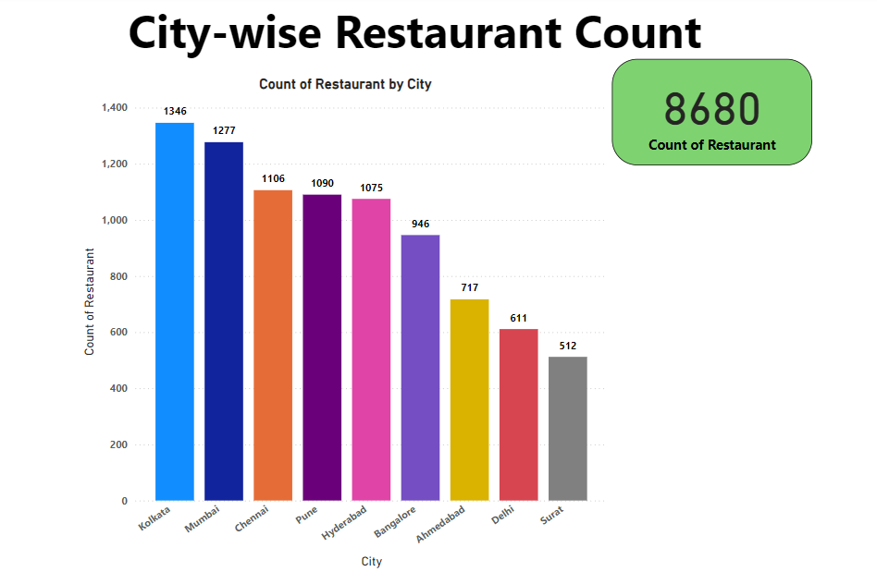

The chart highlights the distribution of restaurants across different cities, showing where Swiggy has a strong presence and where there are opportunities for growth.

Kolkata and Mumbai are key markets with the highest restaurant counts, while cities like Surat and Delhi have room for expansion. This data can guide Swiggy's strategic initiatives to enhance its service and market share in these regions.

**Task 7: Price Analysis**

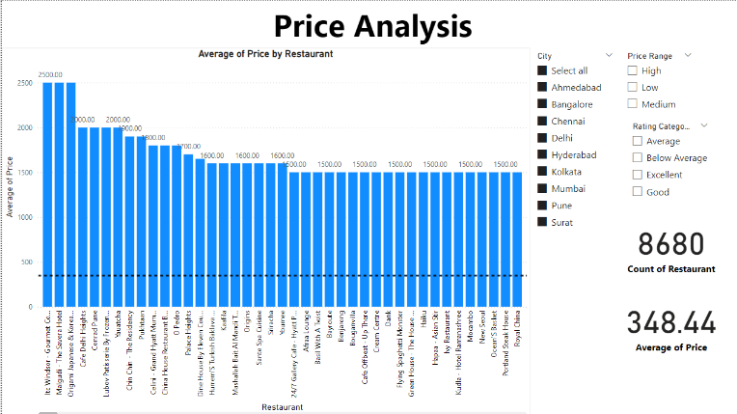

An examination of the average pricing across 8,680 restaurants is shown in the chart. It displays the variety of prices for different restaurants, with "Ilk Vindhyaar Gourmet Co." being the costliest at 2500. The range of prices spans from affordable restaurants to posh places. With an average price of 348.44, this analysis is useful for evaluating the general pricing landscape across various cities and restaurant ratings. Filters enable more segmentation by quality rating, price range, and city, enabling focused insights based on particular standards.

**Task 8: Delivery Time Analysis**

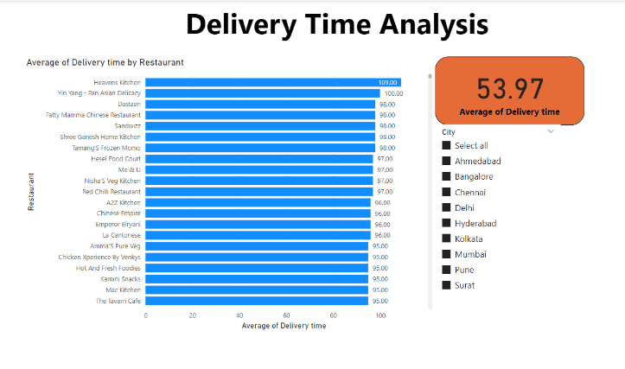

A "Delivery Time Analysis" for a variety of restaurants is displayed in the image; the average delivery time for all locations is 53.97 minutes.

At 109 minutes, Heavens Kitchen has the longest average delivery time.   
Yin Yang - Pan Asian Delicacy follows with 100 minutes.

The delivery timings of other restaurants, such as Sandwizz, Fatty Mamma Chinese Restaurant, and Dastaan, are somewhat shorter, at about 98 minutes.

Which restaurants have lengthier delivery delays may be clearly seen from the statistics, which may have an effect on patron happiness and purchasing decisions. Additionally, the chart has a filter option for distinct cities; nevertheless, the graphic does not show precise city-wise data.

The "Delivery Time Analysis" chart shows that the average delivery time across various restaurants is 53.97 minutes. "Heavens Kitchen" has the longest average delivery time at 109 minutes, while several other restaurants also have relatively high delivery times, ranging from 95 to 100 minutes. The analysis highlights differences in delivery efficiency among the listed restaurants.

**Task 9: Cuisine Analysis**

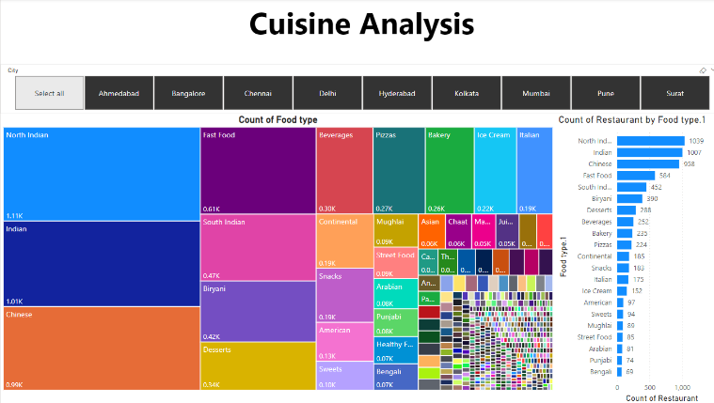

The "Cuisine Analysis" chart shows how different cuisine kinds are distributed among different establishments. With 1,039 restaurants serving it, North Indian cuisine is the most popular, followed by Indian (1,007 restaurants) and Chinese (958 restaurants). Other noteworthy cuisines are South Indian (452 restaurants), Biryani (390 restaurants), and Fast Food (584 restaurants).

The data indicates that there is a wide variety of cuisines accessible, with the most common being Chinese, Indian, and North Indian. Although specific city data is not displayed in the graphic, the chart also allows for filtering by city.

**Task10: Area-wise Restaurant Analysis**

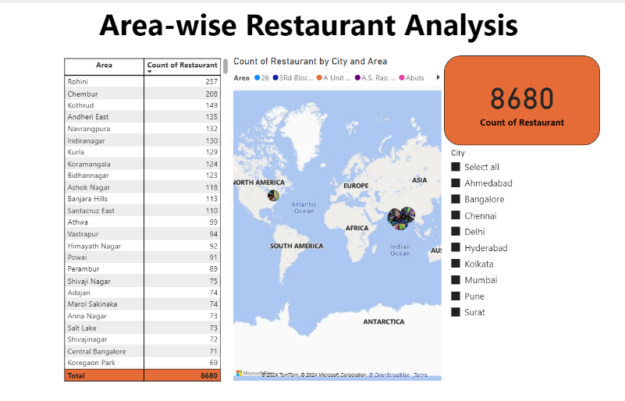

The examination of restaurant distribution by area shows how restaurants are distributed over different regions; certain places have significant numbers of restaurants, while other areas have room for expansion. While developing locations like Athwa and Himayath Nagar present opportunities for growth, key areas like Rohini, Chembur, and Kothrud are essential to Swiggy's operations.

Swiggy can use this data to inform the development of focused strategies that will improve service delivery and increase market penetration in various geographic areas.

**Task 11: Correlation Analysis**

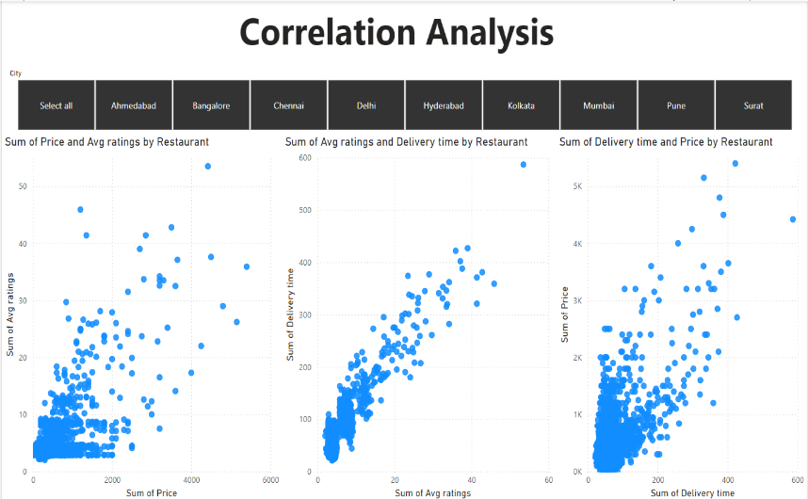

The correlation study provides important light on the ways in which many elements interact to influence restaurant performance. The fact that price alone does not guarantee better reviews and the significance of prompt delivery for excellent ratings are two important lessons learned.

By concentrating on enhancing delivery times and comprehending the various price-rating dynamics to better meet consumer preferences, Swiggy may better optimize its operations with the use of these data.

**Task 12: Customer Feedback Analysis**

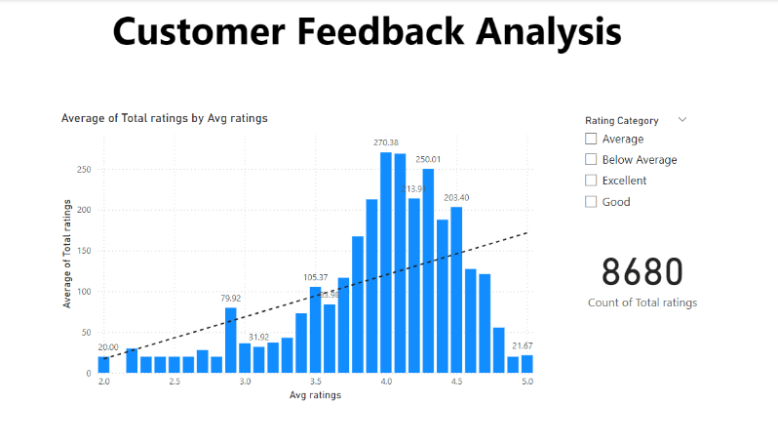

An insightful look at the relationship between average ratings and the volume of customer feedback can be found in the "Customer Feedback Analysis" figure. It emphasizes how crucial it is to uphold strong service standards in order to receive higher ratings, which draw in more feedback and interaction from customers.

In order to move up the rating scale and become more visible and well-liked, restaurants should concentrate on improving their patron experience.

**Task 13: Geographical Mapping**

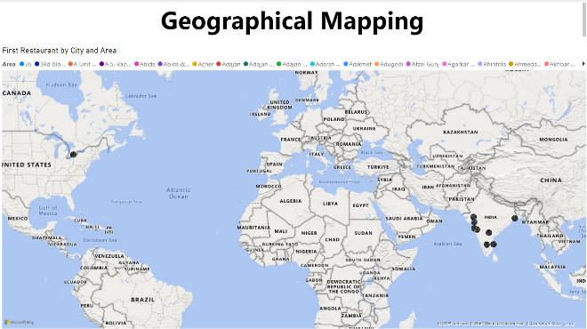

The "Geographical Mapping" chart clearly illustrates the urban focus of the dataset by displaying the concentration of restaurant locations. It gives a visual picture of the restaurants' geographic distribution and highlights how densely populated major Indian cities are with a restaurant. However, the clarity for differentiating particular locations is limited in metropolitan regions due to the dense grouping of points.

**DASHBOARD**

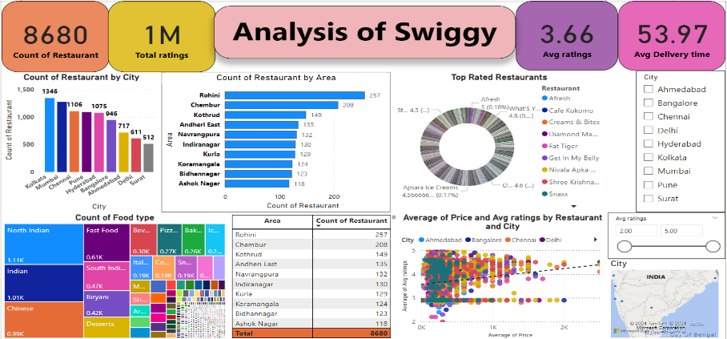

**Observations:**

* **Diverse Cuisine Offerings**: The variety in food types indicates a diverse culinary presence on Swiggy, catering to different tastes and preferences.
* **Ratings and Price Correlation**: Higher prices are generally associated with better ratings, suggesting that customers are willing to pay more for higher quality food and service.
* **Urban Concentration**: Major cities like Kolkata, Mumbai, Chennai, and Bangalore dominate the restaurant count, indicating a strong urban focus.

**Suggestions:**

* Focus on expanding restaurant listings in cities and areas with lower current presence to capture untapped demand.
* Invest in logistics to reduce delivery times, especially in high-demand areas, to boost customer satisfaction and ratings.
* Promote restaurants with higher ratings and faster delivery times to enhance overall user experience.

**Conclusion:**

The dashboard provides a clear summary of Swiggy restaurant data, emphasizing the variety of food options, concentration in large cities, and relationship between price and customer happiness. It gives stakeholders a concise summary of the performance and distribution of restaurants on the platform.

By addressing these areas and leveraging the strengths highlighted in the dashboard, Swiggy can continue to enhance its market presence, customer satisfaction, and overall service quality.